Part 1

1. **Introduction**

Bayerische Motoren Werke AG was founded in 7 March 1916 and is based in Munich, Germany, together with its subsidiaries, develops, manufactures, and sells automobiles and motorcycles, and spare parts and accessories worldwide. It operates through Automotive, Motorcycles, and Financial Services segments. The financial services segment engages in the multi-brand, retail and dealership financing, customer deposit and insurance activities; and provision of fleet financing services under the Alphabet brand.

Following the Brexit trade deal, as well as the Covid-19 pandemic crisis which gave a long-lasting impact in the automotive manufacturing sector. Knowing automotive is a key manufacturing sector for FDI and the UK economy. The impact of the Brexit trade deal on automotive was accounted for 4.9% of foreign direct investment (FDI) projects in the UK between the three financial years 2017-18, 2018-19 and 2019-20, according to figures from the Department for International Trade. Between 2017-18 and 2018-19, automotive FDI projects accounted for 5.2% of all FDI in the UK. This figure fell to around 4.3% in 2019-20. Covid-19 also influenced the supply chain with the Brexit trade deal between the UK and the EU in addition to the extra procedures and paperwork also affected trade and supply chains. Due to the Brexit, there has been a disruption to supply chain with the UK adjusting to the new terms with its biggest trade investors alongside the coronavirus outbreak. The impact of the Brexit dragged the GDP to a percentage of 3% smaller than the EU membership).

This report aims to discover, analyze and evaluate appropriate solutions to BMW business processes in order to strengthen their business. Techniques and tools that include all five activities: strategy analysis, situation investigation, considering perspectives, analyzing needs and defining requirements will be use in the cause of this study to discover ways to increase productivity.

**2. Justification of Tools and Techniques**

For this discussion we will employ the Strategy analysis Michael Porter’s Five Forces Model as we will also use the Context Diagram. The Five Forces Model is used as opposed to the PESTLE analysis technique which helps to understand market dynamics & improve its business continuously. The Porter’s Five Forces identifies and analyzes five competitive forces that shape every industry and helps determine an industry’s weaknesses and strengths. For this study the Five Forces analysis will be used to identify our case study the BMW automotive structure to determine corporate strategy.

For the situation investigation the Rich Picture and UML Context Diagram techniques will be used:

UML Context Diagrams is not necessarily the standard use of UML, but a specific and important implementation of a Use Case Diagram. Context Diagrams will be used to understand the details and boundaries of the system, and also points out the flow of information between the system and external components.

For Consider Perspective a CATWOE analysis and a Power/Interest grid will be utilized. CATWOE (The mnemonic stands for Customer, Actor, Transformation, Worldview, Owner and Environment) technique is an excellent approach to understanding the various perspectives of each stakeholder has within a business that improves businesses. The analysis need, UML use case diagrams and descriptions will be used in decision modelling as it is simple to understand for business people.

The define requirements section will also be employed, ERM, ELM, UML Class and Sequence diagrams will be used. ERM/ERD diagrams are flexible and powerful ways of modelling the relationships and entities in a system (Song et al., 1995) due to their ability to visually present the layout of said system in an appropriate manner. ELH diagrams are strong way to map out the timeline of an entity’s life and the different changes that arises.

**3. Strategy Analysis**

**3.1 Michael Porter’s Five Forces**

**3.1.1 Competitive Rivalry Within the Industry**

Competition is quite fierce in the automobile industry. There are several rivals of BMW in the market like Audi, Mercedes, Skoda, FCA, Ford, Toyota, Tesla and Land Rover. Even if new players cannot enter the market or become a threat overnight, the existing players are quite aggressively investing in marketing as well as research and development to produce innovative vehicle models and grow their market share. Luxury car brands like Audi, Mercedes or Tesla are highly cautious regarding customer experience and passenger safety. These brands focus upon customer experience and technological innovation. They are investing in digitalization and production of environmentally safe car models. Moreover, with growing competition, companies are forming partnerships to strengthen their competitive advantage and produce cars locally for sales in local markets. BMW has also entered into partnerships with other car businesses like Daimler Chrysler and Great Wall Motors of China. While these strategic partnerships are helping the existing brands strengthen their competitive position and customer loyalty, they are also helping them penetrate new markets.

Due to growing intensity of rivalry, BMW has grown its focus upon sustainability, vehicle design, customer experience as well as research and development. There are more factors that help BMW moderate the competitive pressure and include brand equity, supply chain, international manufacturing network as well as marketing. All these factors have helped the BMW group retain its leading position and market share in the automobile industry. However, reducing its focus upon innovation or product quality will lead to loss of market share. So, continuous focus upon R&D as well as customer satisfaction is essential to beat the competitive pressure. The overall intensity of rivalry in the industry is very high.

**3.1.2 Bargaining Power of Customers**

Bargaining power of the customers is an important factor affecting the sales and profitability of any large and global business. There are several factors that affect the bargaining power of customers. In the 21st century, the bargaining power of customers has grown a lot which is due to increased competition as well as higher regulation, changing consumer trends and low switching costs. Now, the customers are well informed and conduct research before making the final purchase. Higher competition has also added to the bargaining power of customers. Every brand is competing to grow its market share and customer base. Most of the leading brands including the closest rivals of BMW are investing heavily in research and development as well as marketing. The focus is now on entire customer experience and not just quality products. Marketing as well as after sales service have also become a core focus for luxury automobile brands. In the case of BMW, some of the leadingfactors that moderate the bargaining power of customers are brand equity, product quality, technological innovation and customer experience. Overall, the bargaining power of BMW customers is moderately high.

**3.1.3 Threat of New Entrants**

The threat of new entrants in the automobile industry is very low which is because of the higher entry and exit barriers. Some of the main barriers that prevent new players from entering the market include fierce competition, large capital investment, need for skilled human resources, technological barriers and brand equity. Any new brand would have to make a considerable capital investment to build a strong source of competitive advantage. Competition in the automobile industry is already quite fierce and the incumbent players make huge investments into research and development as well as marketing to retain their market shares. Apart from that, any new player entering the market will need time and money to build brand recognition and gain market share. None of these things is possible overnight. Except Tesla, there is hardly any new brand that has been able to build a remarkable presence globally in the automobile industry during the recent years. Growing legal regulation of the automobile industry has also made it difficult for new players to enter the market. Not just product quality but passenger safety and sustainability have also become major concerns for auto firms. All these factors discourage new players from entering the automobile industry. The overall industry environment has also become highly challenging. New businesses would also need to invest a lot in building production, supply and distribution networks which works as a barrier to entry.

**3.1.4 Bargaining Power of Supplier**

The bargaining power of suppliers is affected by several factors including the size of the firm, concentration of suppliers in the industry as well as their ability of forward integration. In the automobile industry, the concentration of suppliers is higher compared to the concentration of buyers. BMW works with around 12,000 suppliers located in 70 countries. Several of its supply chain partners are themselves auto firms and the main aim of these partnerships is to produce BMW cars locally in the markets where BMW operates. For example, the company has established BMW Brilliance in China which is a joint venture between BMW and Brilliance Automotive of China to produce and sell BMW cars locally. Additionally, it partnered with the Great Wall Motor of China to produce Electric Mini cars locally. The partnership between Great Wall Motors and BMW is a 50-50 joint venture. In India also, the company has several local supply chain partners that help it produce BMW cars locally for the Indian market. Its supply chain partners in India include Force Motors, ZF Hero Chassis, Draexlmaier India, Tenneco Automotive India as well as Valeo India and Lear India.

The overall bargaining power of BMW supply chain partners in this way gets to become moderately low. BMW enjoys strong brand equity globally and moreover, working in partnership with BMW is an attractive proposition for its suppliers. All these factors offer BMW higher clout in the global automobile industry. However, BMW invests in the education and training of its suppliers and also works to manage its supplier relationships well.

**3.1.5 Threat of Substitute Products**

The threat of substitutes is an important factor that affects demand and profitability of any automobile brand including BMW. The higher the number of substitutes, the higher is the threat to consumer demand and profitability of any brand. While the threat of substitute products for BMW arises from several sources, there are several factors which moderate the threat as well. Main substitutes of BMW include the rival brands in the industry as well as the alternative sources of transportation. There are several rival brands in the market including Volkswagen, Audi, Land Rover, Toyota, Ford, Mercedes, Aston Martin and Lexus. Alternative sources of transportation like cars, buses, taxis and flights also pose a threat before BMW. However, these threats get moderated by the following factors. BMW makes stylish cars and owning one is a matter of class, luxury and prestige for most BMW car owners. Moreover, having your own luxury car means higher convenience in personal life. BMW offers a comparatively better customer experience than most substitutes. The passenger safety and convenience as well as luxury which BMW car offers is matched by very few rival brands in the market. The overall threat of substitutes for BMW is moderate. Higher popularity and customer loyalty also act to moderate the threat from substitute products.

**3.2 PESTLE Analysis**

**3.2.1 Political**

BMW is one the leading luxury car manufacturers of the world. There are two major political factors which have recently affected BMW. Firstly, the escalation of the trade war between U.S.A. and China. And, secondly, Brexit i.e., Britain’s exit from the EU can have a negative impact on the company as it will increase trade restrictions causing increase in the costs and decrease in the volume.

**3.2.2 Economical**

Apart from the European Union, a major chunk BMW’s revenue comes from China and The United States of Nation. So, any uncertainty prevailing in these countries can adversely affect BMW. The increased investment done by BMW for the electrification of their drivetrain systems (which is responsible for providing power to the wheels) can increase its costs significantly.

**3.2.3 Social**

The BMW Group has a presence in more than 140 nations. The BMW group has 3 divisions i.e., the automotive segment, the motorcycles and the financial services. A major chunk of BMW’s revenues come from its automotive segment with all its brands catering to the premium segment.

**3.2.4 Technological**

BMW Group realizes the importance to integrate technology in its vehicles and also in the services that it provides. BMU has opened an Autonomous Driving Campus in Germany recently which will be a facilitator in designing of the automated vehicles.

**3.2.5 Legal**

BMW Group has been subject to various legal problems all over the globe. Noncompliance may result in product liability claims or the loss of an operating license, and complying with new governmental laws, regulations, or policies will increase capital and research costs.

**3.2.6 Environmental**

Also, with the introduction of electric vehicles, the CO2 emissions have further dropped. The BMW i3 is fully electric with zero carbon emissions. While their hybrid models have C02 emission as less as 45g/km.

**4. Investigation Situation**

**4.1 Rich picture**



Figure 1 – Rich picture

This rich picture depicts the relationships between BMW employees, customers, stakeholders, and the systems they use. It also illustrates some of the issues the BMW Group is experiencing, such as covid-19, Brexit, competition from other automotive brands such as Ford and Tesla. Increment in taxation (this is a built-in system by which the government of a country/state takes money from people or businesses and spend the collected money on things such as health, education, and education) was also identified in the above rich picture chart-flow.

**4.2 Context Diagrams**

**4.2.1 Production System**



Figure 2 – Production System Context Diagram

**4.2.2 Finance System**



Figure 3 – Finance System Context Diagram

**4.2.3 Customer service System**



Figure 4 – Customer System Context Diagram

**5. Consider Perspective 5.1 CATWOE**

|  |  |  |  |  |
| --- | --- | --- | --- | --- |
| Stakeholders | Mr. Oliver Zipse | Dr. Andreas Wendt | Dr. Nicolas Peter | Customer |
| C | Electric car buyers | Employees | Finance | Customer needs affordable luxury sport car, electric car |
| A | Mr. Oliver Zipse, Dr. Andreas Wendt, Dr. Nicolas Peter | Mr. Oliver Zipse, Dr. Andreas Wendt | Dr. Nicolas Peter | Customer service |
| T | Positioning the business for growth, Complying t to the government rule on gas emission | Engage and re-energize the team, enable employees to improve the reliability of data | Discrepancy between purchasing and reports, Ensuring proper payment of taxes and timely payment of employees | Own a quality sport car without paying too much money |
| W | Electrifying purchasing, manufacturing process not causing advance effect to the environment | Team work will provide best services thereby causing the business to succeed easily | Providing a good finance system | Electric vehicles do not emit toxic gas, reduce fuel cost and require low maintenance |
| O | Mr. Oliver Zipse | Mr. Oliver Zipse, Dr. Andreas Wendt | Mr. Oliver Zipse, Dr. Nicolas Peter | customer |
| E | New innovative drive-in technology so as to help in curbing Greenhouse Gas Emission and environmental Sustainability |  | Covid-19 outbreak affecting the supply, Increase in exchange and interest rate to foreign exchange rate, Tax laws | Low income due to covid-19 break out |

Figure 5 – CATWOE Analysis

**5.2 Power/Interest Grid**

|  |  |  |
| --- | --- | --- |
|  |  | **Mr. Oliver Zipse** |
|  | **Dr. Nicolas Peter** | **Dr. Andreas Wendt**  **Head of Purchasing & Supplier Network and Member of Management Board.** |
|  | **Customer** |  |

Low Medium High

**Interest**

**X-axis: Interest**

**Y-axis: Power**

Figure 6 – Power/Interest Grid

The Power/Interest Grid is a business technique that is used to categorize stakeholders based on their power or rather their influence and interest in a business project. This simple grid above explains the level of authority a stakeholder has in a company or a project. For our case study the BMW Subsidiaries, Mr. Oliver Zipse, as the company's owner, possess considerable power and interest, owing to the fact that the company is his and he makes business decisions. Dr. Andreas Wendt retains a high level of interest but less power than Mr. Oliver Zipse, though he has a proven track record of successfully implementing business transformation in a competitive environment. The Production Manager and the Customer Relationship Officer are also concerned with the development of the company's product. They aid in the improvement of product quality as well as the identification of new customer segments that will be beneficial to the brand. Dr. Nicolas Peter, the company's Chief Financial Officer, has medium power and medium interest in the company's financial growth. The saying customers are king, customers have an interest because they use the services provided to them and have high regard for the brand which they utilize.

**6. Analyze Needs**

**6.1 Production System**

**6.1.1 Use Case Diagram**



Figure 7 – Production System Use Case Diagram

6.1.2 Use Case Descriptions

|  |  |
| --- | --- |
| Use Case | Production |
| Description | The Production Manager makes a monthly plan of production a product, customer's interest can be considered and the supplier supplies the company the parts needed |
| Actors | Customers who purchase vehicles, Suppliers |
| Standard Scenario | 1. Customer orders for vehicles 2. The Production Manager makes a monthly plan depending on customers depend 3. The Supplier supplies the company the parts needed for manufacturing of vehicle based on demands 4. There's a monthly dispatch to customers |
| Alternate Scenarios | N/A |

**6.2 Finance System**

**6.2.1 Use Case Diagram**



Figure 8 – Finance System Use Case Diagram

6.2.2 Use Case Descriptions

|  |  |
| --- | --- |
| Use Case | Calculate Income, Pay salary |
| Description | The customer makes payment and the accountant record the payment the Owner gives the accountant the financial statement of the company  The accountant pays the salary of the employees monthly |
| Actors | Customer, Accountant, Employees, Owner |
| Standard Scenario | 1. Customer make payment 2. Accountant make records of the payment 3. The accountant receives the yearly financial information from the owners. 4. The accountant calculates the income 5. The accountant calculates and deduct tax 6. The accountant calculates the revenue 7. The accountant calculates the gross profit 8. The accountant gives the owner the income figures  9. The Accountant pays the employee base on the hours of work per day |
| Alternate Scenarios | N/A |

**6.3 Customer service System**

**6.3.1 Use Case Diagram**



Figure 9 – Customer service System Use Case Diagram

6.3.2 Use Case Descriptions

|  |  |
| --- | --- |
| Description | The Customer place then the salesperson records the order while the customer relation officer follow up with the customer |
| Actors | Customer, Customer relations, Salesperson, Supervisor |
| Standard Scenario | 1. Customer places order 2. Salesperson check status and document the order 3. The customer relation officer follows up the customer. 4. The supervisor document the customer satisfaction |
| Alternate Scenarios | N/A |

**7. Define Requirements**

**7.1 ERM**

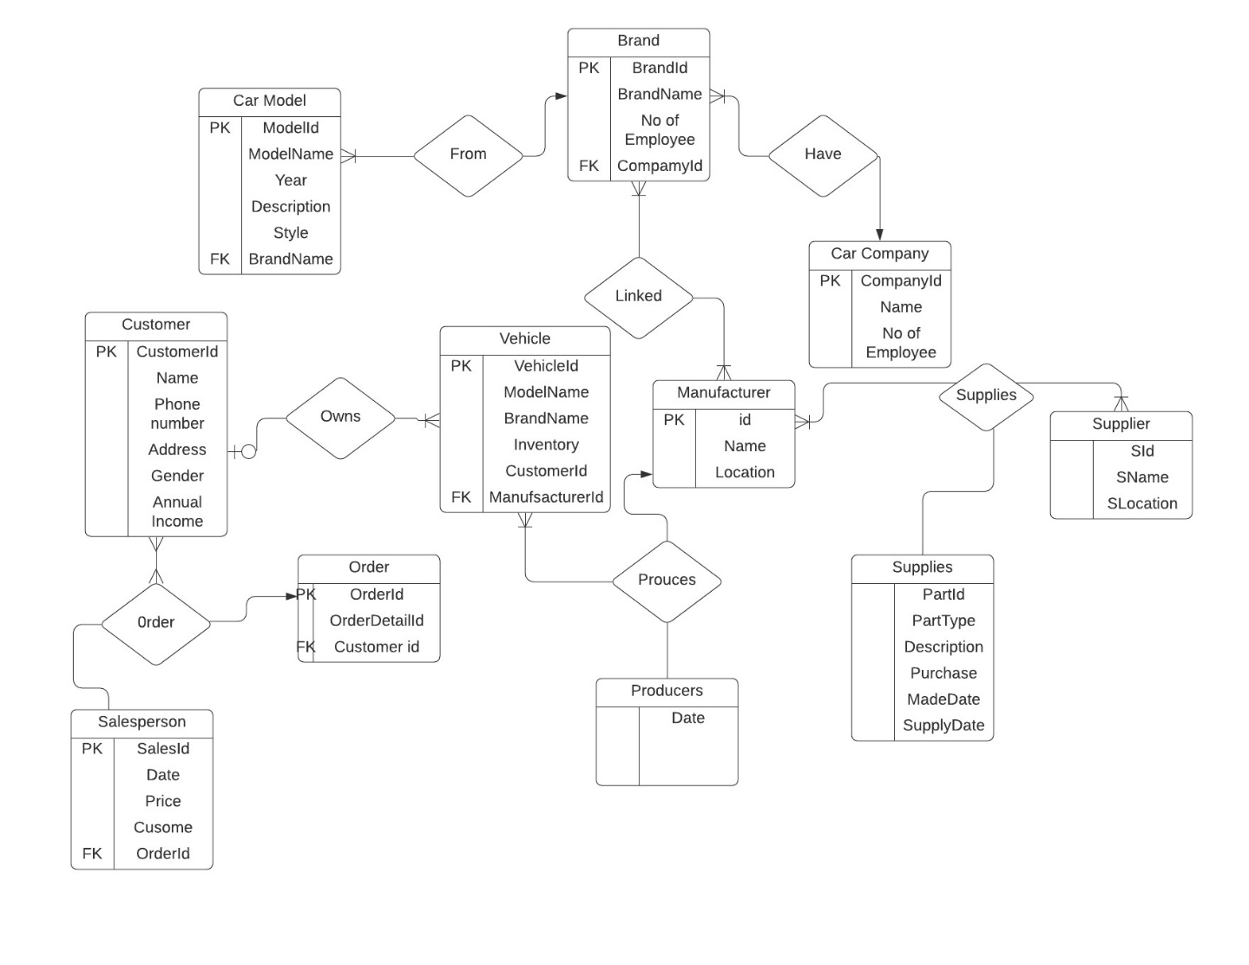

Figure 10 – Bayerische Motoren Werke AG ERM Diagram

**7.2 Class Diagram**

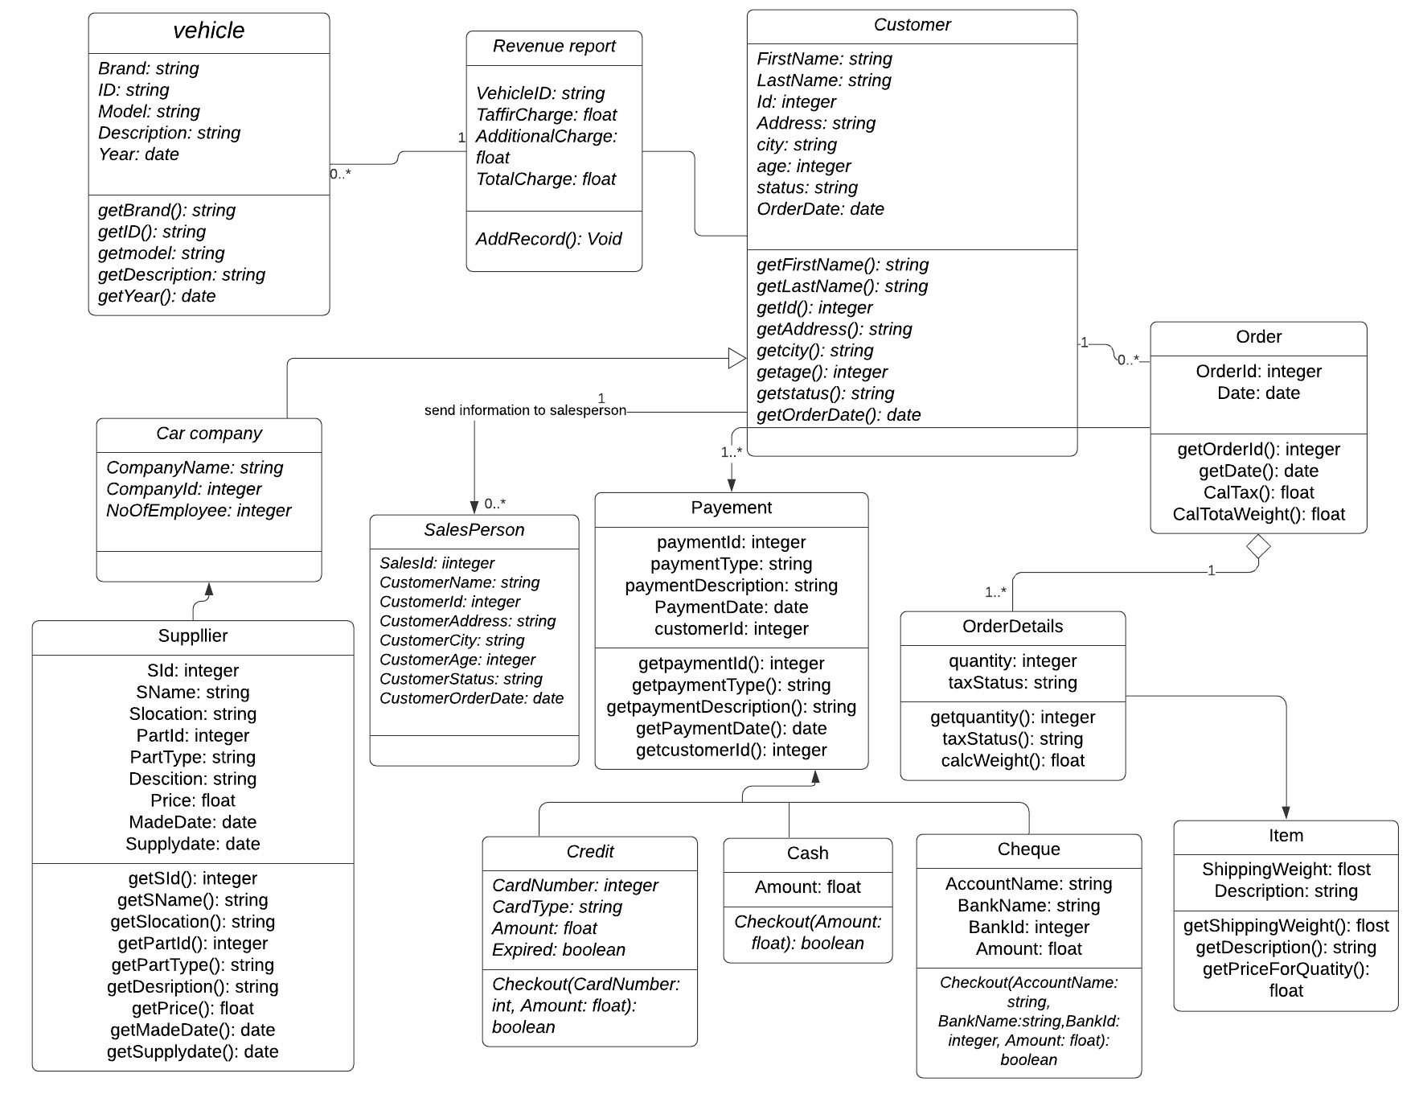

Figure 11 – Bayerische Motoren Werke AG Class Diagram

**8. Observations**

The business approaches used in this study shows that for any automotive company to advance in productivity and profitability there ought to be some measures of managerial skill, input of technology and high level of trust between the customers and the organization since this is the biggest challenge the automotive marketers face. Also utilizing the power online presence as a defense, such that customers see their products at top of some search engine SERP. While building a customer to business relationship, there is need for biding the competitive keywords across the marketplace.

The aftermath of Brexit trade deal is another key issue that has impacted the company's business and income. Brexit causes additional expenses connected with increased customs charges and tariffs, delays in customs processing and the interpretation and implementation of the trade agreement with the EU, and currency rate volatility, all of which influence group revenues, earnings, and cash flows. Bayerische Motoren Werke AG can leverage on some strategies like call-only campaigns and remarketing strategy, due to the comparison among other brands remarketing helps in registering the brands image in the minds of its customers through the use of ads.

The Rich picture also shows concerns about positioning the business for growth as a result of the tragic effects of the COVID-19 pandemic, as well as complying with government regulations on gas emissions. This can be addressed if the company improves the quality of their products and introduces innovative, alternative fuel vehicles, such as electrification and self-driving autonomous vehicles.

**9. Evaluation**

For evaluation, the techniques we used in analyzing the business as a result of the Brexit and Covid-19 pandemic were well selected and carefully used in drawing adequate business decisions. The ERM diagrams used in this study clearly illustrates a visual starting point of an organization database and present a relationship that defines the entities, their attributes, draw a random inter-relationship between them. The diagram presented in the study was carefully designed using the Lucid Chart alongside the Microsoft Visio software for proper visualization of the organization’s logical database structure. Lucid chart improves data security by offering a wide range of security features, such as domain control, dedicated support, and simple license provisioning.

Porters’ Five Forces was also a good fit for analyzing the BMW Subsidiaries because it allowed for an in-depth exploration of the company's overall standing in the marketplace, as well as an easy-to-understand grid that quickly shows the intensity of each force. The Porter’s Five Forces being a business analysis model helped us to explain how to sustain the business level of profitability, identify the company’s strategy and also act as a yardstick to measure competition intensity, attractiveness, and how to sustain the profitability of the business.

The Rich Picture was used to explore, acknowledge and define the situation that influences the organization due to the Brexit and Coronavirus effect expressed through diagrams to create a mental model. On the other hand, context diagram helped in pin pointing the relationship that needs consideration so as to improve the understanding process of the business.

The CATWOE was used to stimulates multiple approaches and identify problem areas, and sought solutions that can influence the stakeholders and Power Interest Grid are useful in identifying stakeholder motives and intentions, however there may not be enough stakeholders with dramatically different interests. The ERM provided valuable insight, the Class diagrams also provided a reasonable insight too to an extent was too rigid to fully grasp how the BMW Group operate on a daily basis.

The overview of our study was intended to show how businesses are being affected by the outbreak of the Covid-19 pandemic whereas organizations seek different insightful measures that will give them the leverage to stay in the marketplace with the challenges faced by Brexit’s trade deal political crisis.